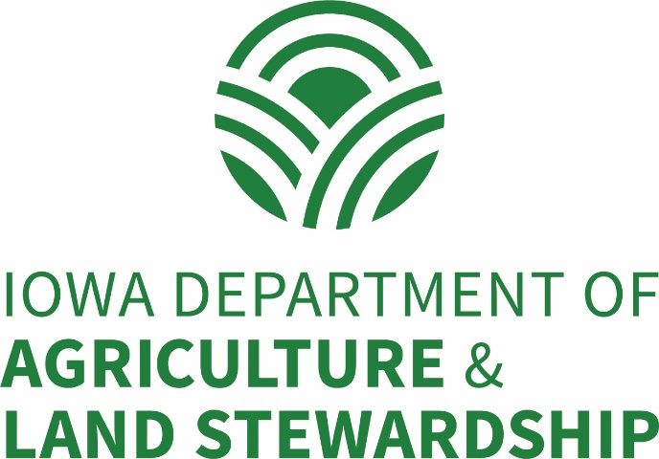

Request for Proposals
Iowa Department of Agriculture and Land Stewardship

Water Quality Initiative
Nutrient Reduction Strategy Targeted Watershed Implementation Projects

Proposals are Due:
NO LATER THAN 4:30 PM
Thursday, April 30, 2020

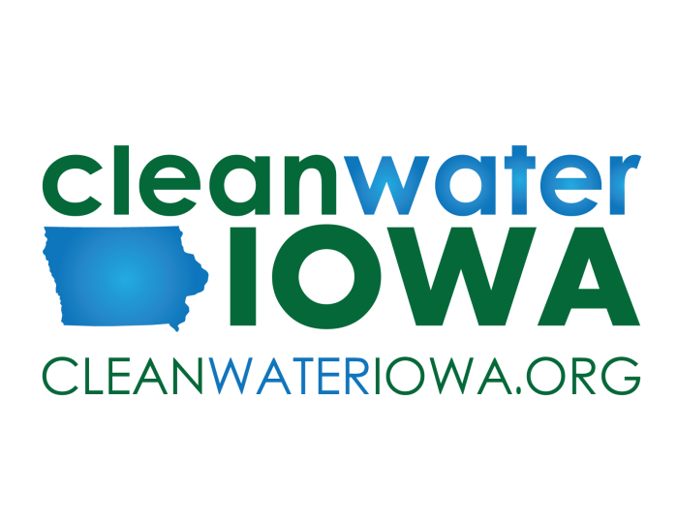
ProJECT Objectives and Desired Outcomes

The Iowa Department of Agriculture and Land Stewardship (IDALS) is issuing this request for proposals (RFP) to provide funding for watershed based targeted implementation projects to reduce the loss of nutrients to waters of Iowa. These projects will focus on increased adoption and implementation of conservation practices in alignment with the Iowa Nutrient Reduction Strategy (NRS) objectives. The NRS is available for review at http://www.nutrientstrategy.iastate.edu.

Eligible applicants must have demonstrated experience effectively delivering priority nutrient reduction based practices and have established strong partnerships that are contributing significant resources to the project. Selected projects will utilize monitoring, assessment and planning tools that will prioritize and coordinate implementation efforts around the installation of conservation practices in their respective watershed areas. Reports and assessments will be required to document project progress and economic value of efforts in alignment with work plan objectives. Successful projects serve as regional models for scalable expansion into surrounding watersheds.

Project SummarY

Projects will be evaluated on their demonstrated experience and proposed approach to perform the following objectives:

- Ability to increase and expand implementation of NRS practices utilizing cost share from a diverse funding resources and partnerships.
- Ability to target conservation implementation to locations and/or specific cropping systems based on demonstrated experience and evaluated need for integration of these practices.
- Established local support, partnerships and willing landowners/farmers to adopt and expand use of NRS priority practices.
- Ability to leverage additional resources from stakeholders and other partner(s) agencies to expand scale and impact of the project on a regional basis and beyond the current project area.
- Plan to monitor, assess and evaluate project impacts in alignment with water quality and socioeconomic goals.
- Projects that focus on infrastructure-based and that have a larger impact on nutrient reductions will receive priority consideration for funding (i.e. wetlands, bioreactors, grade stabilization structures, saturated buffers, etc.).

Priority Watershed Areas

Existing watershed demonstration projects located within priority HUC8 watersheds that have been identified by the Water Resources Coordinating Council (WRCC) will receive priority consideration. Projects should evaluate the current project area and opportunity for geographic expansion as part of the application development. The priority HUC8 watersheds are:
- Floyd | - East Nishnabotna | - West Nishnabotna
- North Raccoon | - Boone | - Middle Cedar
- Skunk | - South Skunk | - Turkey

Eligible Applicants

Soil and Water Conservation Districts (SWCDs), counties, county conservation boards, cities or other units of government, not-for-profit non-governmental organizations (NGO’s) authorized by the secretary of state, public water supply utilities or watershed management authorities are eligible to submit proposals. Due to the nature of this program and the emphasis on actionable plans/designs and documentation supportive of the nutrient reduction strategy, applicants must collaborate with respective Regional Coordinator and/or other IDALS staff on application development. Applicants are also strongly encouraged to partner with stakeholders that will benefit from installation of non-point, agricultural conservation practices and would be able to assist with outreach and promotion.

The Primary Grantee must include documentation of their ability to provide appropriate fiscal management of the funds requested in the project proposal. If the group is unable to meet this requirement themselves, they may include documentation of their partnership with an entity that has an appropriate fiscal management structure in place in order to be considered an eligible applicant.

Eligible Expenses

Eligible expenses include:
- Technical Assistance (Salary/Benefits/Travel/Training) needs for project implementation.
- Outreach/Education components such as field days, publications, signs, and informational meetings.
- Contractual costs for assistance with project implementation components such as engineering, monitoring, assessment and outreach.
- Cost-sharing funds for NRS approved practices (see application for details on practice cost-share funds).

Project Duration

Projects applying under this RFP may request up to three years of funding. It is anticipated project funds will be available July 1, 2020.

DISBURSEMENT OF FUNDS

The Primary Grantee will be responsible for submitting payment requests to IDALS. Payments for Technical
Assistance/Staffing will be available through a monthly advance payment schedule, which will be outlined in the project agreement. All other expense payments will be made on cost reimbursement basis. The Grantee will submit invoices and/or other required documentation to IDALS for the disbursement of funds. An explanation of the process and the required documentation will be provided to the Grantee by IDALS as part of the project agreement process.

Proposal details

Proposals must be submitted following the format and page limits provided. Maps and letters of support will not count against stated page limits. Letters of support are required to confirm the roles/contributions of identified partners. The projected timeline for the complete proposal process is detailed below:

- RFP open: February 7, 2020
- RFP closes: April 30, 2020
- Selections made: June 2, 2020
- Projected start: July 1, 2020

PROPOSAL Review & Selection

Eligible proposals will be reviewed by IDALS. IDALS intends to provide notice of award described above. Upon selection, successful applicants will enter into contract negotiation with IDALS to begin on the anticipated start date.

Proposal Evaluation Factors

- Proven and demonstrated experience implementing and/or promoting NRS practices within the priority watershed in a targeted and efficient manner
- Demonstrated experience utilizing practice cost-share funding from a variety/combination of sources (state, federal, local government, and/or private, etc.)
- Established strong partnerships, local support and landowner willingness/participation levels to commit financial and in-kind support to the project
- Scope and objectives that propose conservation infrastructure and local priority NRS practice implementation on an increased pace and scale in alignment with the Iowa Nutrient Reduction Strategy goals
- Assessment, monitoring and evaluation plan to measure progress and accomplishments in alignment with the project work plan objectives
- Ability and readiness to proceed quickly with planned implementation approach upon project approval

Proposals must note their current status as it relates to WQI Demonstration Watershed Projects (#4 on the proposal template. Applications will be scored and weighted according to status to better evaluate project proposals of past accomplishments and experience.

Proposal ASSISTANCE
Water Quality Initiative Coordinators – Matt Lechtenberg, 515-281-3857 or matthew.lechtenberg@iowaagriculture.gov or Matt McDonald, 515-725-1037 or matt.mcdonald@iowaagriculture.gov

For help with proposals please obtain assistance from the Regional or Basin Coordinator for your area (Page 8):

- Western Iowa - Bob Waters - 712-336-3782 or Bob.Waters@Iowaagriculture.gov
- Northeast Iowa - Jeff Tisl -563-422-6201 or Jeff.Tisl@Iowaagriculture.gov
- Southeast Iowa - James Martin -319-337-2322 ext. 4836 or James.Martin@Iowaagriculture.gov

Special Notes

The Iowa Department of Agriculture and Land Stewardship (IDALS) prohibits discrimination in its programs on the basis of race, color, national origin, sex, religion, age, disability, political beliefs and marital or familial status. (Not all prohibited bases apply to all programs.)

Distribution of proposals is limited to people involved in the review process, but note that all proposals and subsequent reports and related information are in the public domain. All reports related to funded projects will be made available to all interested parties in printed, electronic, or other means of communication, without discrimination.

Names, addresses and telephone numbers of Project Coordinators (from funded projects) may be provided to interested news entities, potential project participants, or organizations for subsequent inquiries. Proposals are used in the peer review process and submission of a proposal establishes consent by the author for appropriate distribution to fulfill review requirements.

Proposals approved for funding will be required to enter into a project agreement with IDALS. Sponsors of approved projects will be required to submit quarterly and final project reports utilizing forms and guidance provided by IDALS.

The Iowa Department of Agriculture and Land Stewardship’s (IDALS) release of public records is governed by Iowa Code Chapter 22. Respondents are encouraged to familiarize themselves with Chapter 22 before submitting a Proposal. IDALS will copy and produce public records upon request as required to comply with Chapter 22 and will treat all information submitted by a Respondent as non-confidential records unless Respondent requests specific parts of the Proposal be treated as confidential at the time of the submission as set forth herein AND the information is confidential under Iowa or other applicable law. See following link for Form 22 – Request for Confidentiality https://das.iowa.gov/sites/default/files/procurement/pdf/Form22-RFP.pdf

Procedure for Submitting Proposals

Submit one electronic copy of your project proposal to IDALS. Arrival date and time of the electronic copy will be used to determine whether a proposal has been submitted on time. Proposals must be received by 4:30 PM on the closing date. Proposals will be accepted by either of the following methods:

- Submit the electronic copy of the proposal on a storage medium (CD, Flash drive, etc.) to the address below:

Iowa Department of Agriculture and Land Stewardship
Division of Soil Conservation & Water Quality
c/o Nicole Gubbels
502 East 9th Street
Des Moines IA 50319

- Submit the electronic file containing your proposal in an attachment by e-mail addressed to nicole.gubbels@iowaagriculture.gov. The file size limit for submission of proposals by e-mail is 10MB in size. Hard copies of the proposal will not be accepted without an electronic copy. If you need assistance submitting your proposal, please contact Nicky Gubbels at 515-281-5851 or nicole.gubbels@iowaagriculture.gov.

WATER QUALITY INITIATIVE
nutrient reduction Strategy Targeted watershed implemention project
Proposal for funding assistance

Iowa Department of Agriculture & Land Stewardship

Proposal Cover Sheet: (1 page maximum)

Provide the Following Information on a Proposal Cover Sheet.

- Project Title:
Applicant Entity:
Contact Person:
Address:
Phone:
E-mail:

- Authorized signature of lead applicant______________________ Date_________

- List the proposed watersheds or focus area of the project in relationship to priority HUC8 watershed(s):

- Current Project Status (select one):
___Current or past WQI Demonstration Watershed Project
___New WQI Watershed Project
- Proposed project duration, including anticipated start and completion dates:

- Include a listing of all project partners (letters of support are required for all project partners):

- Provide a budget summary, utilizing the format shown here:

 | IDALS Request | Partner Contributions | Landowner Contributions | Total Budget
Year 1
Year 2
Year 3
Overall

Proposal Narrative: (4 page maximum)
Provide brief, yet thorough, responses to the following set of questions, with the number and title for each of the sections at the top of the corresponding response.

- Project Background and Overview
Provide a brief overview of the project highlighting key accomplishments and demonstrated successes. Address the following questions in your response:
- Provide a brief background of the project including current and proposed focus area, accomplishments to date, and key partnerships.
- Describe project successes, growth and current momentum that will lead to increased implementation and targeted adoption of key NRS practices within and beyond the project area.

- Project Objectives
Provide a brief description of the project’s proposed approach to addressing the following objectives:
Project Implementation Approach: Describe the planned practice implementation approach and list the specific actions that your project will take to advance the objectives of the Iowa Nutrient Reduction Strategy. The implementation approach should describe both targeted infrastructure and management practices and be based on expansion of current successful models within the proposed project area and from other successful projects.
Project Management and Partnerships: Describe how this project will be organized and managed to achieve the project’s intended objectives. Describe the specific roles of partners in achieving these objectives and the added benefit to the advancement of strategy objectives.
Project Outreach: How will this project communicate directly (one-on-one) with landowners, farmers and other partner stakeholders key to the project’s success in order to achieve the intended objectives? Describe how you intend to engage the target audience and how your approach will lead to greater practice implementation.

- Project Assessment, Monitoring and Evaluation
Provide a brief description of the project’s proposed approach to addressing the following objectives:

Describe how the project will assess the value of practice implementation (both cost shared and non-cost shared) and evaluate the success of project objectives utilizing monitoring and assessment tools. Include discussion of impacts on economic value, water quality and nutrient reduction value.

How will project results be documented and disseminated to local, regional, and state-level stakeholders in order to connect project outcomes to the overall objectives of the Iowa Nutrient Reduction Strategy?

How will the project leaders, participants, and stakeholders know if the project is successful? What information will be collected to measure success, and how will it be assessed and communicated? Indicators could include, but not limited to these categories: inputs, attitudes, land/practice changes, water quality, etc.

Application Budget: (2 page maximum, including narrative)
Use the table format shown on the following page to provide an estimated budget for the project. You are encouraged to copy and paste this table here into your application and use Excel to assist with putting the table together. Be sure to review column and row totals for accuracy. In addition to the tables, include a narrative providing the following information:

- Explain the amount and type of all local and partner contributions that will be made to the project. This may be in the form of in-kind contributions, cash contributions, or the commitment of other program funds to be used in conjunction with the financial assistance provided by the project. Make sure that the role of staff whose costs are included in the budget is clear in the proposal.

- Practices included in the project should be listed in the budget. Add more rows as necessary if needed.
  - Practice(s) using WQI funds must be tied to practices highlighted in the Iowa Nutrient Reduction Strategy.
  - Describe method for delivering cost-share assistance to eligible applicants. Are there any unique ways of cost sharing these practices?
  - Landowner contribution for practices should be accounted for in the budget.
  - Other funding sources for practices such as, WQI Statewide, RCPP, MRBI, EQIP, etc. must be listed in the budget.
  - Management practice funds requested from IDALS must not exceed 50% of the total cost of installation. Edge-of-field practices may not exceed 75% of the total cost of installation. Incentive based practices must be based on 50% of total costs and applicant must be able to provide documentation upon request.

- Provide detailed information on any anticipated subcontracts that will be funded through this project, including identified work products and costs associated with the subcontract.

- If the project is currently under contract through IDALS and already receiving state or federal funds, please do not include unobligated or unspent IDALS funds from the current project term when developing the proposed project budget or application.

Table 1. Budget Template

Component | Year 1 | Year 2 | Year 3 | Total | WQI | Local Match | Match Source(s)*
Technical Assistance | $ | $ | $ | $ | $ | $
Information/Education | $ | $ | $ | $ | $ | $
Travel/Training | $ | $ | $ | $ | $ | $
Supplies | $ | $ | $ | $ | $ | $
Contractual (list below)
Contract | $ | $ | $ | $ | $ | $
Contract | $ | $ | $ | $ | $ | $
(insert lines as needed)
Practices (list & number)
 | $ | $ | $ | $ | $ | $
 | $ | $ | $ | $ | $ | $
 | $ | $ | $ | $ | $ | $
(add lines as needed)
TOTALS | $ | $ | $ | $ | $ | $

*Include landowner contributions in local match (partner and landowner from budget summary table). Use acronyms for other partners and identify acronyms in budget narrative.

Maps and Supporting Data:
Please attach any maps and other supportive data relevant to the application as Exhibits, labeling each Exhibit at the top of the first page.

Letters of support from identified partners are required for the application. Identified partners that are providing funding (cash or in-kind) contributions must indicate these proposed contributions in their letter of support. For applications led by Soil and Water Conservation Districts, a letter of support from the respective Area Resource Conservationist must be included with the letters of support.

Regional Coordinator Areas

